Arduino Lesson 18
Servo Motors
- Intro
The servo is a kind of position servo drive, constructed with the shell, circuit board, no core motor, gear and the position detector. Its operation theory is receiver or MCU sending the signal to the servo, its internal have a standard circuit, produce 20 ms cycle, 1.5 ms width standard signal, will compared the DC bias voltage with potentiometer voltage then get the output voltage difference. It recognize the rotation through circuit IC, and then drive no core motor rotate, transmit the power to swing arm through the reduction gear, sent back signal at the same time by the position detector to determine whether has positioned. It applys to those control system need Angle changing and remain the changing. When the motor speed is fixed, make the voltage difference as 0 and stop running through the cascade reduction gear drive the potentiometer.General servo rotating Angle range is 0 to 180 degrees.
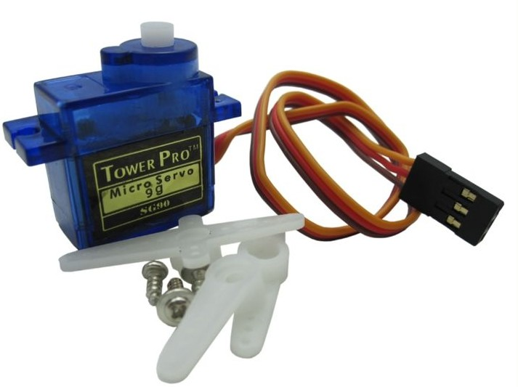
Servo Motor has lost of standard，but all of them has 3 external
wires.
You can tell by the 3 colors,brown(Gound),red(+5v),orange(PWM
Signal). But wire color is different as different brands. 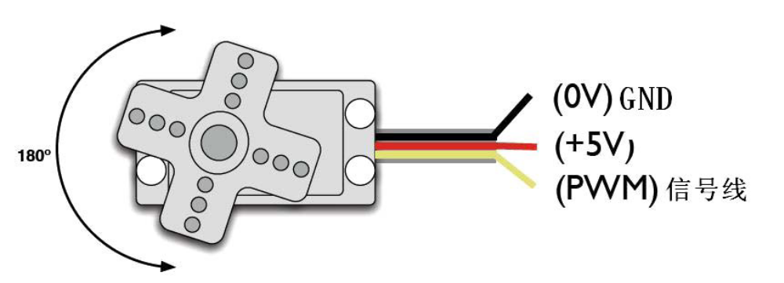
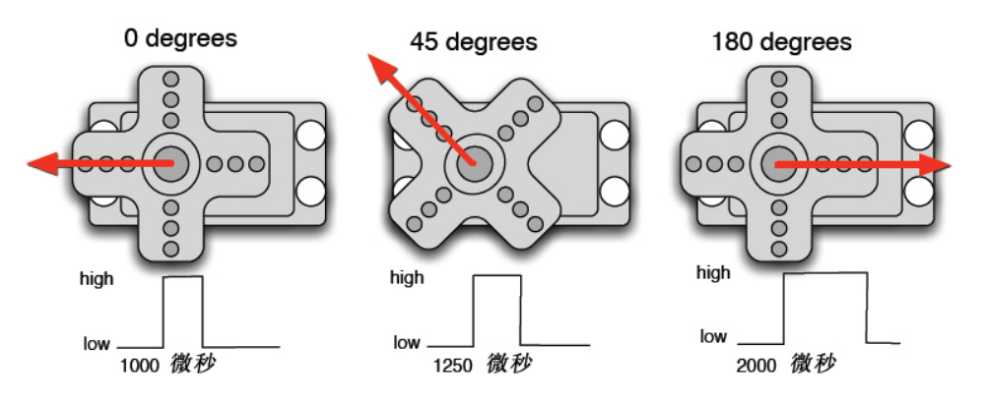
- Parts Requried
SG90 Servo Motor x 1
Jumper wires x 1 Bundle
There are two methods to control the servo motor with Arduino. First one is the Ordinary digital sensor interface of Arduino produces different duty ratio square wave, simulatively create the signal to position the servo.
Second one is using the Arduino build-in function,the advantageof this
method is programming, disadvantage is you can only control 2
channel,because Arduino build-in function can only use #9 #10
interface.The driving ability of Arduino is limited. So you need external
power supply when you control more than 1 servo motors.

Method 1
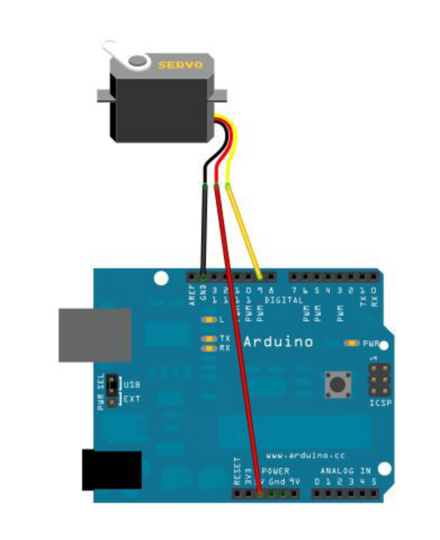
Connect servo #9 interface,program to make the servo turn to appointed angle as the input figure, and display the angle on the lcd.
- Program A for reference
int servopin=9;// Define the digital interface #9,connect servo signal wire
int myangle;// Define Angle variables
int pulsewidth;// Define Pulse width variables
int val;
void servopulse(int servopin,int myangle)// Define a pulse function
{
pulsewidth=(myangle*11)+500;//Turn the angle into Pulse width value 500-2480
digitalWrite(servopin,HIGH);// Turn up the servo interface level
delayMicroseconds(pulsewidth);//Delay the microseconds of the pulse width value
digitalWrite(servopin,LOW);// Turn down the servo interface level

delay(20-pulsewidth/1000);
}
void setup()
{
pinMode(servopin,OUTPUT);// Set servo interface as output
Serial.begin(9600);//Connect to serial port,baud rate is 9600. Serial.println("servo=o_seral_simple ready" ) ;
}
void loop()//Turn 0-9 into 0-180 degree angle, and make the LED blink relevantly.
{
val=Serial.read();//Read serial port’s value
if(val>'0'&&val<='9')
{
val=val-'0';// Turn characteristic quantity into numerical variable
val=val*(180/9);// Turn figure into angle degree
Serial.print("moving servo to ");
Serial.print(val,DEC);
Serial.println();
for(int i=0;i<=50;i++) // Give the servo enough time to rotate to appointed angle
{
servopulse(servopin,val);//Quote pulse function
}
}
}
Method 2
Now we give you a brief intro about the build-in functions of Arduino.Belows are the common statement.
- attach（interface）——Set servo motor interface,only #9 and #10 can be used.
- write（angle）——Set the rotate angle,could be 0°to 180°。
- read（）——read the angles,means read the values on last
command- write( )
4、attached（）——Determine if the parameters of servo have been sent to servo interface.
5、detach（）——Separate the servo and interface,#9 / #10 interface can be still used sas PWM interface.
Note：the format of above statement all like this“servo variablename.detailed statement” For example,myservo.attach(9)。
still connect the servo on #9 interface。
- Program B for reference
#include <Servo.h>// Define a header file.Note:you can invoke Servo function by click Sketch-Import library-Servo in Arduino menu.And space required between #include and <Servo.h>when you input,otherwise program could go wrong.

Servo myservo;// Define the steering gear variable names
void setup()
{
myservo.attach(9);//Define servo interface(#9 /10 is ok,disadvantage is you can only control 2
}
void loop()
{
myservo.write(90);// Set the steering gear rotating Angle
}
Above show you how to control the servo motor, you may choose what you like base on the advantage and disadvantage.

